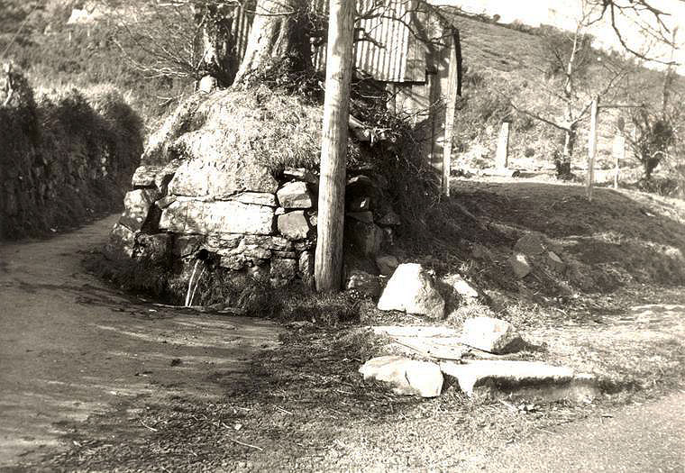
Tuesday 24th May
7 pm Village Hall

The Heritage Group has held 3 meetings and now decided to set up a Constitution which will enable
members to apply for funding and assistance to further a clear purpose:

To research and preserve the heritage and history of Sticklepath and the surrounding area,
and promote an understanding of the character of the District.

Everyone is welcome to be part of the group.

For more details http://www.sticklepath.org/
Cllr Derek Moore 840316 derekmoore60@hotmail.com

Sticklepath Heritage Group
1st AGM

